Embedding GIS in Disaster Simulation

Shengnan Wu, Larry Shuman, Bopaya Bidanda, Matthew Kelley, Ken Sochats, Carey Balaban, University of Pittsburgh

Abstract

Disasters are complex events that involve multiple actors trying to gain control over and manage rapidly changing situations. We have developed an "all hazards" disaster modeling system called the Dynamic Discrete Disaster Simulation System (D4S2) that seamlessly integrates ArcGIS 9.2, Rockwell Automation's Arena discrete event simulation, a custom built rule based decision modeling system, and a control interface that mirrors an emergency operations center. Each component informs the others continuously of decisions, status changes, and other situational variables that have changed as the event(s) unfold. D4S2 provides a circumstance independent laboratory for testing how the type and scale of an event, situational variables and command decisions affect responders' efficiency and effectiveness in dealing with disasters. This paper discusses the construction of the system and the insights gleaned as a result of its application to disaster scenarios in Pittsburgh.

Introduction
The Center for National Preparedness at the University of Pittsburgh has been developing an advanced simulation system to simulate the response to emergencies. This simulation system, we call the Dynamic Discrete Disaster Simulation System (D4S2), is a core component of our overarching approach which we call the Pittsburgh Framework for Emergency Preparedness and Response. While our initial focus has been on emergency response, we recognize that the framework has wider applicability in areas such as: urban and regional planning, military operations, etc.

D4S2 seamlessly integrates a geographic information system (GIS), discrete event simulation, a custom built rule based decision modeling system and a control interface that mirrors an emergency operations center. The model’s geo-database contains over 100 layers of geographic, asset and other geo-referenced information. The simulation model is built dynamically from the geo-database and situational data about the event allowing us to create any number, type and size of emergency events. The decision model contains rules that codify standards, training, best practices, exercises and research on first responders, emergency managers, dispatchers, the public, terrorists, other actors and environmental factors. Each component informs the others continuously of decisions, status changes, and other situational variables that have changed as the event(s) unfold. The model provides a circumstance independent laboratory for testing how the type and scale of an event, situational variables and command decisions affect responders’ efficiency and effectiveness in dealing with disasters.

D4S2 is designed for three areas of application:
- Planning – measuring the effectiveness of policies and procedures as well as optimizing routing, procedures and resource allocation
- Training – Allowing users to step forward and retrace the simulation process. Providing operational definition for situational awareness.
- 3. – Real time emergency management support and offline research, simulation and optimization.

Background

Natural disasters and terrorist attacks are crises that compel urgent coordinated responses by state and local agencies. These events present a challenge to first responders, who must react to unfamiliar scenarios in a decisive manner to minimize the impact on life and property. These events present an equally, if not greater, challenge to a state’s governing authorities, who must efficiently coordinate the efforts of numerous response agencies – both horizontally among agencies and vertically between local and state agencies. State leaders must also efficiently and effectively allocate federal assistance when it becomes available. The broad range of possible crises only increases the potential burden on state governments to recognize the nature, stage, and scale of an event and respond quickly and appropriately. Without the appropriate tools and training, the danger always exists that state-level leaders may unwittingly exacerbate rather than mitigate the damage. Emergency response has often been characterized as a “wicked” problem where the type, size, scale, location, victims and many other parameters are outside the control of the responders.

Further compounding the complexities of response are the realities of the environment in which the response must take place. This is most evident in a city such as Pittsburgh where our capacity to respond is further shaped by topography, rivers, bridges, tunnels and other characteristics of the region,
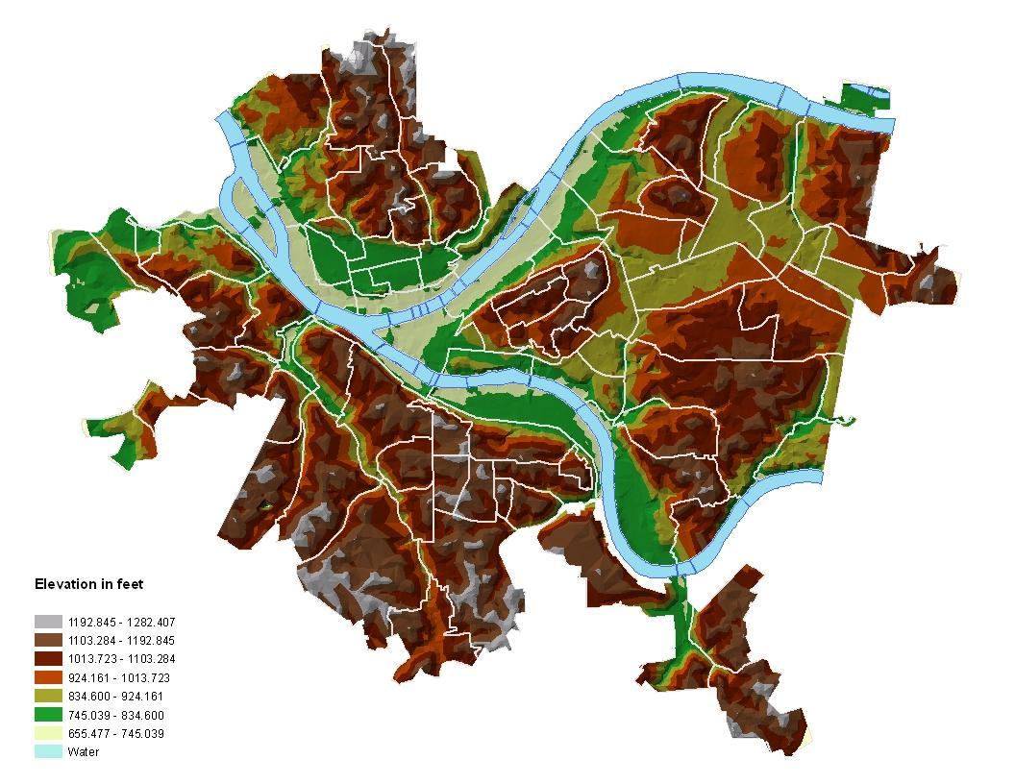

System Overview

The architecture of the Dynamic Discrete Disaster Decision Simulation System is shown below. D4S2 uses ESRI’s ArcGIS 9.2 as its GIS component, Rockwell’s Arena as its simulation engine and Microsoft’s SQLServer as its database.

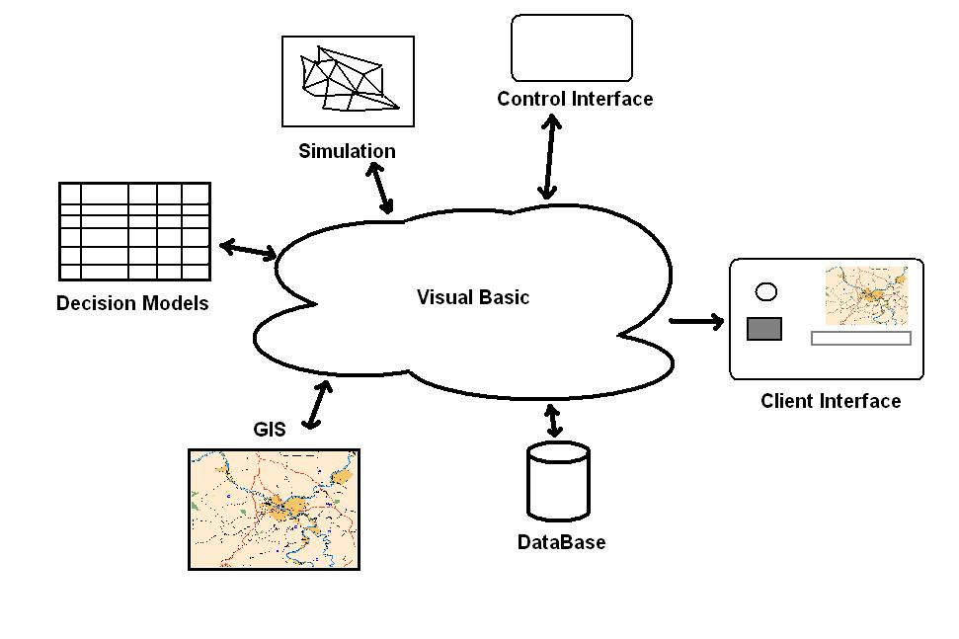

We elected to use this architecture and these components to take full advantage of the ability to link to leading products with sophisticated capabilities. The rest of the system was custom built either because there was no commercially available product that met our needs or to allow for high levels of customization.

The custom software seamlessly integrates the components and provides interfaces for control and interaction. In operation, the GIS, Simulation, Decision Models and the Control Interface continuously interact with each other. When a simulated emergency event occurs, data from the GIS may be used to generate a simulation whose results trigger some decision rules which then may update the GIS and simulation and so on.

GIS plays two important roles in the system. First it is used as a resource for extracting the emergency assets available, the victims and assets affected and the “connectivity” of the area. Second, GIS provides an excellent mechanism for portraying the current state of the emergency, what the response community calls “situational awareness”.

While the system operates in a highly adaptive fashion, the outline below presents the major steps in a linear mode.

- Develop and describe a disaster scenario. Initially we have focused on the Department of Homeland Security standard disaster scenarios. We are also using their metrics for measuring consequences.

- Using GIS, the system delineates the geographic scope of the disaster and extracts the relevant geographic features, transportation routes, buildings, population and other important entities. GIS is also used to provide network solutions (e.g. shortest route, spanning tree).

- Create database tables that describe the relevant entities and their attributes.

- Create the appropriate aggregation of these entities for simulation and decision support.

- Build the decision models and simulation problem.

- Operate the simulation and its interacting decision models.

- Dynamically display the results of the simulation/decision process on a user interface.
  - Map display
  - Dashboard display

- Checkpoint the simulation/decision progress into a database table(s).
  - Could interrupt the simulation, use the partial results as boundary conditions for new simulation that “zooms-in”. Back to step 2.

- Analyze the simulation.

One of the most important features of D4S2 is its ability to dynamically build a network simulation model. The map below shows an ArcMap display of an area of downtown Pittsburgh. D4S2 has extracted (and labeled) key nodes (intersections) as candidates for the simulation. In the case from which this diagram was extracted, a hazardous chemical train wreck was hypothesized at node 1.

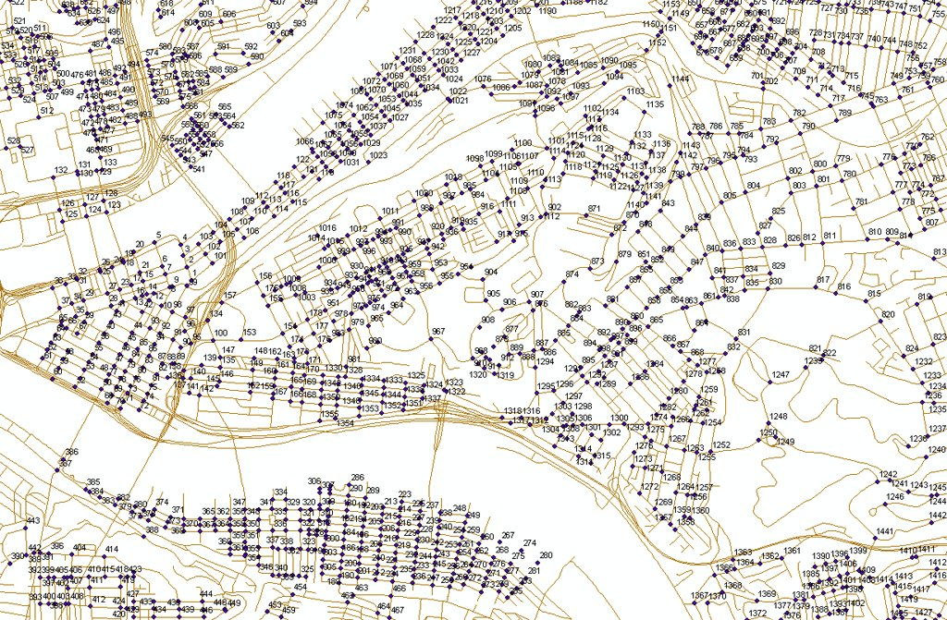

The map below shows a “zoom” of the area affected.

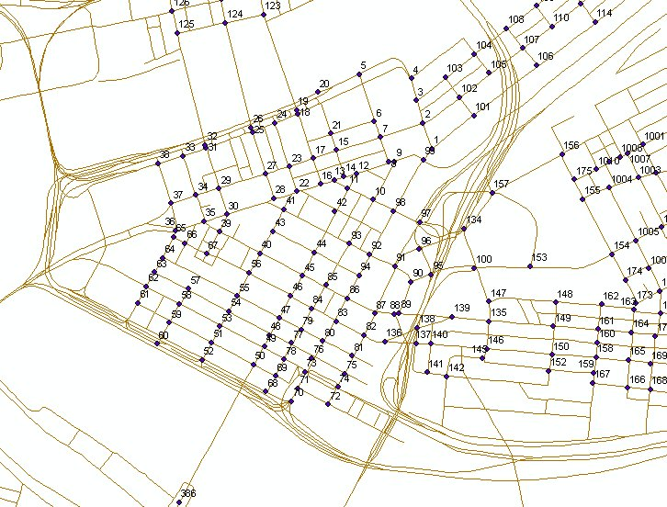

D4S2 now constructs a queuing based simulation model of this area. A schematic of the model is shown below. 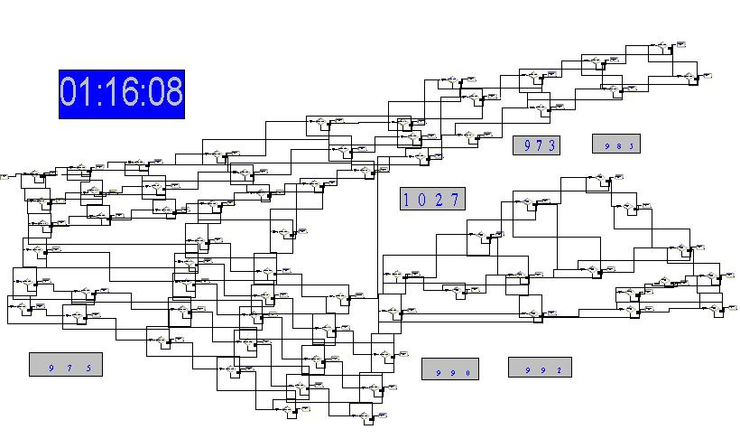

This model is designed to simulate:
- The evacuation of victims out of the area.
- The deployment of emergency resources (EMS, fire, police Hazmat, etc.)
- The transport of casualties to the appropriate treatment facilities.

Decision Models

We developed a decision model based on standard rule-based reasoning from artificial intelligence. The decision modeler is unique in that it uses a standard SQL database management system to store and retrieve the rules. This allows us to create a very large rule base and provides an interface consistent with the other system modules.

We developed a rule format that allows us to specify the rule and to relate the rules to rule sets, actors charges with executing the rules. Tagging the rules with ID and warrants allow us to identify the origin of the rule and create “explanation” when necessary. Rule executions are catalogued in a database table allowing backtracking.

Rule Format
<Condition1><Condition2>…:<Consequence1><Consequence2>… {Actor}{Probability}{Warrant}{Risk}{ID}

Example
<IncidentType “Chemical Spill”>: <Dispatch Fire><Dispatch HazMat> <Dispatch Police><AreaStrategy Evacuate>…{Actor Commander}{P 1.00} {Warrant NIMS(1.25)}{Risk 1.3 7.4}{27}

Rules are grouped into rule sets as a result of their derivation. Sources of rule sets are:

- Standards – NIMS, NFPA, FEMA, etc.
- Subject Matter Experts – Police, fire, EMS, Hazmat, etc.
- Best Practices
- Emergency Plans
- Other oral or written policies, procedures or practices.

Rules are triggered when the state of the system, GIS, simulation, or user input changes. Rules can change the state of the system, e.g. GIS – rearranging assets, simulation – changing parameters, or by changing or firing other rules.

System Operation
Much of essence of D4S2 as discussed in the previous sections is transparent to the user. This section describes the operation of the system from the user’s perspective.

Simulation Control Interface
Designed as an expert system, the interface seen in the figure below is intended for emergency management personal and researchers. The control interface has two primary modes. The first mode when the user is process of constructing a simulation. This is when the “Simulation Build” and “Network map” tab are active. The second mode is where the users review and analyze the simulation results (Simulation Monitor and Simulation Overview tab active). We will describe the construction mode in detail here and dive into get to the analysis mode a bit later.

Construction Mode
Constructing a simulation consists of two primary functions. First, is to set parameters that describe the actual disaster event and secondly is to generate a network with which to run the simulation. Below is a list of parameters and their descriptions that are currently being set in the interface:

- Date/Time – Date and time of day that the event takes place to account for traffic, daylight, resource availability, weekend and holiday adjustments
- Event Type – Fifteen disaster event types as defined by the US Department of Homeland Security
- Update Interval – Number of minutes between each data capture by the system for analysis
- Affected – Number of people affected by the disaster
- Replication – Number of times the simulation will run
- Event Node –Location of the event
- Number of Nodes – Number of nodes with which to run the simulation

Parameter adjustments made during the build process impact many areas throughout the simulation including dispatch rules, resource allocation, travel times, protocols, casualty distribution, etc.. Casualty distribution (deaths, life threat, severe threat, minor/moderate threat, and Ok threat) is a function of the event type. Although, the distribution can be further adjusted after the event type is designated.

Control Interface
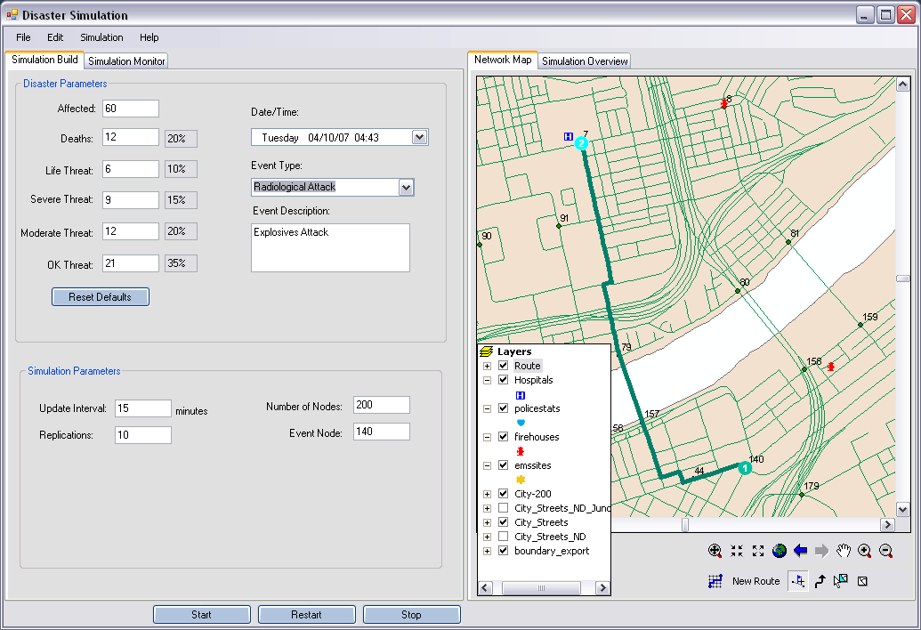

Embedding functionality from ESRI ArcEngine version 9.2 in a .NET form allows the interface to contain an interactive map. Although the interface tools are in their infancy, the following is a description of the process to generate a simulation network. Using the map a user selects an area with which to conduct the simulation. Tools are now being developed to allow users to add / remove response resources, critical nodes, damaged infrastructure, and traffic congestion hotspots.

The simulation process is now ready to be started by pressing the Run button. An additional process is needed to build the network into a usable network from the components selected with the interfaces interactive map. In this process a network optimization algorithms constructs the node set, connections, and travel rates for the simulation engine (Rockwell Arena version 10).

Analysis Mode
Analysis modes begins after the Run button is pressed and the simulation completes. These tabs contain both information about the simulation as a whole (Simulation Overview tab) and details at each of the designated time intervals The simulation overview chart shows the total number of people remaining at the scene over each time interval. Multiple lines on the chart further delineate the people at the scene by threat type. Users can customize the chart by selecting / deselecting various threat type check boxes and pressing Refresh Graph.

Simulation Overview Interface
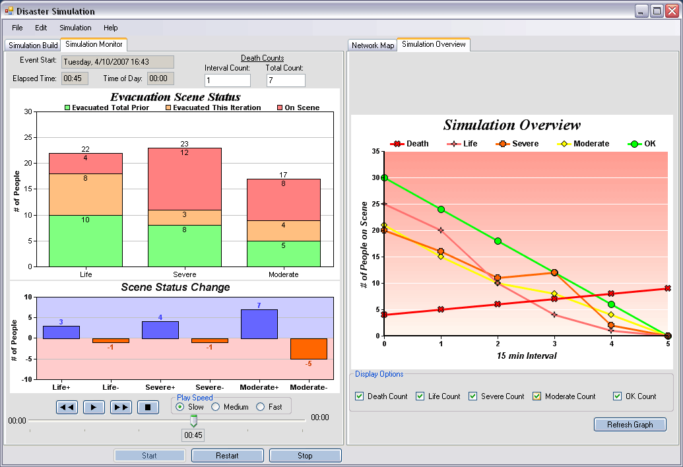

We are continuously developing tools to further enhance analysis capabilities. Currently a double stacked chart show results at each time interval. The top chart contains information about what evacuations took place in a interval as well as the total evacuations up to that time.
- Green represents the total number of people evacuated (by threat type) prior to the latest group of evacuees
- Orange represents the to number of people evacuated (by threat type) during the latest time interval
- Red represents the number of people (by threat type) that are remaining at the scene to be evacuated

Built into the simulation process are health degradation and improvement curves that capture movement between threat types. For instance, throughout the response citizens and responders themselves might become injured and be moved from the ok status to minor/moderate status. Effects of these degradation and improvement curves can be seen on the bottom chart.

Once every life, severe, and minor/moderate threat casualty has been evacuated the simulation ends. Users can replay the simulation, in the form of an animation, at various speeds by selecting a play speed and pressing on the Play button.

Simulation Results Interface
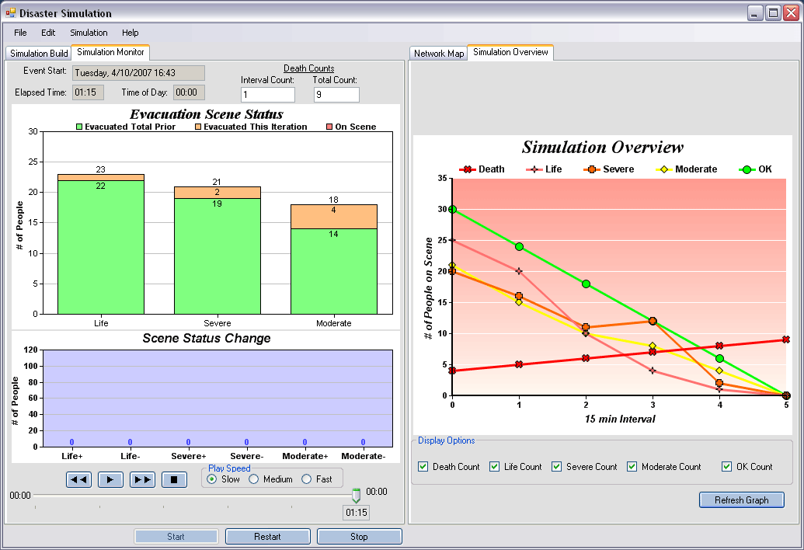

Users can also re-run a simulation after adjusting parameters or generating a new network. Additional functionality is available, such as loading existing simulations, viewing an Arena animation, viewing hospital/route usage maps and exporting the resulting data (note - data is also available in the database used for the simulation).

Future Work

Now that our system is operational, we are going to calibrate it with data from previous response histories and exercises.

From a research perspective we plan to carry on our work with studies/development such as:
- Creation of a “topology” of response for the city. What areas have poor response characteristics?
- Identify and map bottleneck intersections. Devise alternative routing plans.
- Test the system’s effectiveness as an interface for emergency managers.
- Expand the system capabilities to reuse simulations.
- Optimize the geo-location of response assets.
- Optimize the rules for “All-hazards” approaches.
- Integrate real time sensor data.

References

1 RURALSIM was developed under Department of Transportation Contract DOT-8S-8-02028.
2 Shuman, LJ, H. Wolfe and MJ Gunter, “RURALSIM: The Design and Implementation of a Rural EMS Simulator,” Journal of the Society for Health Systems, 3 (3), 1992, pp. 54-71.
3 Shuman, LJ, H. Wolfe, J. Ames IV, M. Etschmaier, and J. Sepulveda, “RURALSIM: A Simulation Model for Designing and Evaluating Rural EMS systems,” in C. Tilquin, editor, Systems Science in Health Care, Vol. II, Toronto: Pergamon Press, pp. 961-973, 1981
4 Shuman, LJ, J. Sepulveda, H. Wolfe and G. Esposito, “Computer Modeling of Rural Emergency Medical Services Delivery Systems,” Journal of the World Association for Disaster Medicine, Vol 1, Supplement 1, pp. 44-48 (1985).
5 JP Lai, L. Shuman, B. Bidanda and C. Lai “A Surrogate Objective Approach To Simulation Optimization,” paper to be presented at the Industrial Engineering Research Conference, Atlanta, GA, May 2006.
6 JP Lai, L. Shuman, B. Bidanda and C. Lai “Optimizing System Parameters Of A Large Scale Distribution Facility By Simulation Meta Modeling,” paper to be presented at the Flexible Automation and Intelligent Manufacturing Conference, Limrick, Ireland, June 2006.
7 J. Banks “Panel session: the future of simulation” Proceedings of the 2001 winter simulation conference, pp. 1453-1460 (2001)
8 A. M. Law “Simulation-based optimization” Proceedings of the 2002 Winter Simulation Conference, pp. 41-44 (2002)
9 S. Andradottir “ Simulation optimization: integrating research and practice” INFORMS Journal on Computing, vol. 14, No. 3, pp.216-219 (2002)
10 Banks, B. Carson, J.S. II. Nelson, B.L. Nicol, D.M. DISCRETE-EVENT SYSTEM SIMULATION, 3rd ed. Saddle River, New Jersey: Prentice Hall, 2001, 489-459.
11 F. Glover, J. P. Kelly and M. Laguna. New Advances and Applications of Combining Simulation and Optimization. Proceedings of the 1996 Winter Simulation Conference, pp 144-152 (1996)
12 Glover, F., “Tabu Search, Part I,” ORSA Journal on Computing, Vol. 1, pp. 190-206 (1989).
13 F. Glover, M. Laguna and R. Marti (2003) “Scatter search,” Advances in Evolutionary Computing: Theory and Applications, A. Ghosh and S.Tsutsui (eds.), Springer-Verlag, New York, 2003, pp. 519-537

